A Case Study of World Population Predictions based on Population Census Dataset

Team Members :

Karthick Prasanna P -CB.PS.I5DAS22026

Viren Namo - CB.PS.I5DAS22059

Vishnuvaradhan M- CB.PS.I5DAS22060

Name: A Case Study of World population Predictions based on population census Dataset.

Abstract :

Population dynamics play a crucial role in shaping economic, social, and environmental policies worldwide. This study leverages a comprehensive dataset containing historical and recent population data for various countries, enabling an in-depth analysis of population growth trends, density variations, and demographic shifts. By utilizing predictive modeling techniques, we aim to forecast future population growth and assess its implications on resource allocation, urban planning, and sustainability. This case study provides insights into population growth rates, density distributions, and continent-wise trends to help policymakers and researchers make data-driven decisions for sustainable development.

Data Information :

The dataset consists of global population statistics spanning multiple years. Key columns include:

* **Rank**: Position of a country based on its population size.
* **CCA3**: Three-letter country code.
* **Country**: Name of the country.
* **Continent**: The continent where the country is located.
* **Population Data (1970-2023)**: Year-wise population count.
* **Area (km²)**: Total land area of the country.
* **Density (km²)**: Population density (population per square kilometre).
* **Growth Rate**: Annual percentage growth in population.
* **World Percentage**: The proportion of the world's population that resides in the given country

**What do we Learn from the Dataset ?**

**Population Growth Trends:**

We can observe how global population has evolved from 1970 to 2023 and identify key patterns in growth rates.Countries like India and China dominate the global population, but China's growth rate has slowed while India’s continues to rise.Some developed countries (e.g., Japan, Germany) are experiencing population decline due to low birth rates and aging populations.

**Regional and Continental Differences:**

**Asia** is the most populous continent, followed by Africa, where many countries have the highest growth rates.EuropeandNorthAmerica show slower population growth due to urbanization, lifestyle changes, and economic factors.Africa’srapidgrowth suggests future economic and infrastructural challenges but also potential for labor force expansion.

**Growth Rate Analysis**

Some countries (e.g., Nigeria**,** Pakistan) have highgrowthrates, signaling future population booms.Others (e.g., China**,** Russia) are decliningorstabilizing, impacting workforce availability and economic growth.

**World Population Distribution**

A few large countries account for the majority of the world's population (e.g., the top10countries make up more than 50% of the global population).The worldpercentagecolumn shows which countries contribute most to the global population.

**Population Density & Urbanization Impact:**

Countries with highpopulationdensity (e.g., India**,** Bangladesh) face infrastructure, housing, and environmental challenges.Low**-**densitycountries (e.g., **Australia, Canada**) have vast land but lower population pressure.Understanding density helps in urban planning, resource allocation, and policymaking.

**Graph Centralities :**

**Degree Centrality:**

Degree centrality is the simplest and most intuitive centrality measure. It calculates the number of direct connections (edges) a node has. In a social network context, a person with high degree centrality has many direct connections or friends. Nodes with high degree centrality are often referred to as "hubs" because they connect to many other nodes.

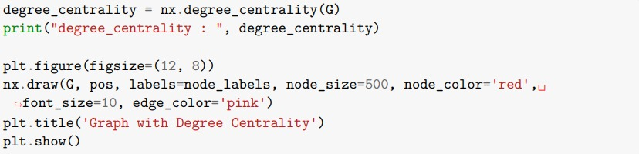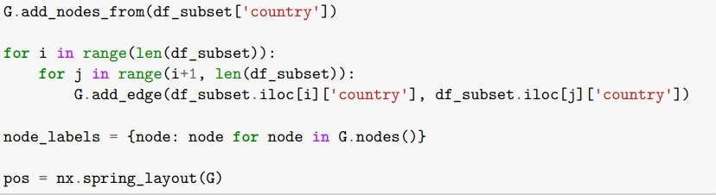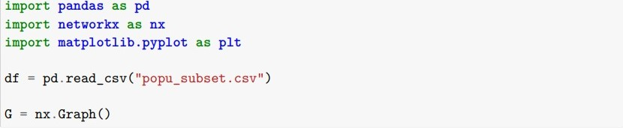Input:

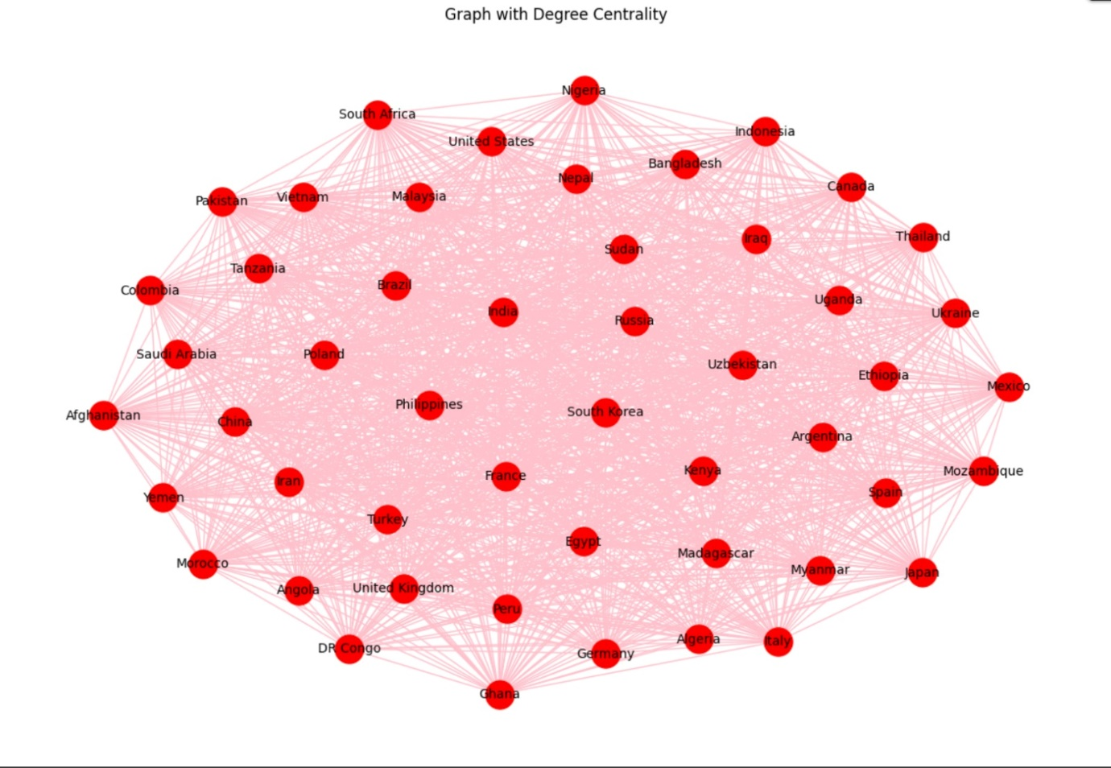

Inference:

Countries with larger node sizes have stronger direct connections, possibly representing regional hubs or influential countries with shared attributes (e.g., high population, same continent, or large trade partners).

These countries play significant roles in maintaining immediate ties, whether economic, geographic, or demographic.

Their removal could disrupt regional cohesion or alliances within the network.

**Betweenness Centrality:**

Betweenness centrality quantifies the extent to which a node lies on the shortest paths between other nodes. A node with high betweenness centrality acts as a bridge or broker between different parts of the network. These nodes have high influence over information flow because many of the shortest paths pass through them. They can control or influence the communication and interaction within the network.

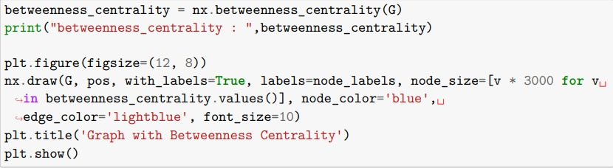Input:



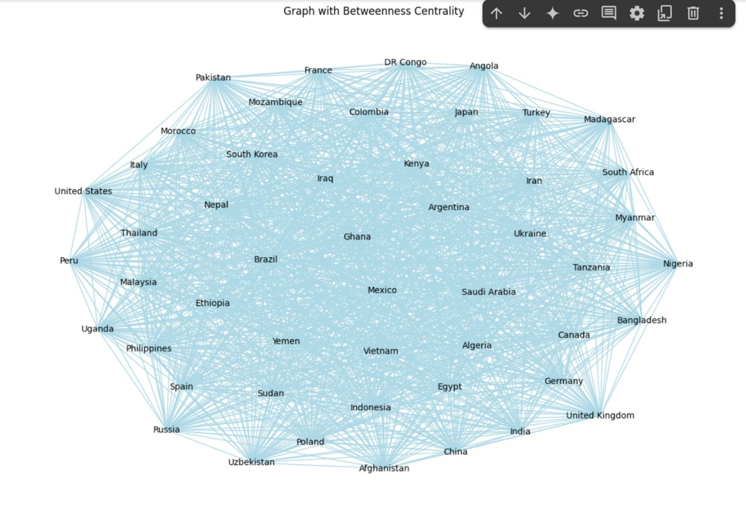

Inference:

Countries with higher betweenness centrality control the flow of influence or information between continents or country groups.

They might represent strategic countries linking various regions—examples could be countries geographically or diplomatically connecting large continents (e.g., Turkey connecting Europe and Asia, or Egypt linking Africa and the Middle East).

Their removal could fragment global connectivity, isolating certain regions from broader interaction.

**Closeness Centrality:**

Closeness centrality measures how close a node is to all other nodes in the network. It calculates the average shortest path length from a given node to all other nodes. Nodes with high closeness centrality are considered central because they can reach other nodes quickly. They often play a crucial role in spreading information or influence through the network.

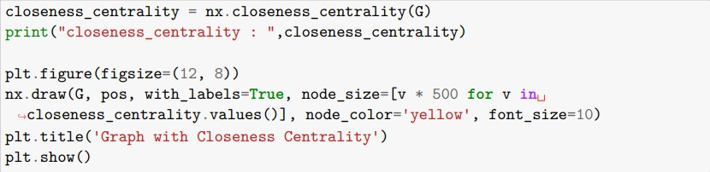Input:



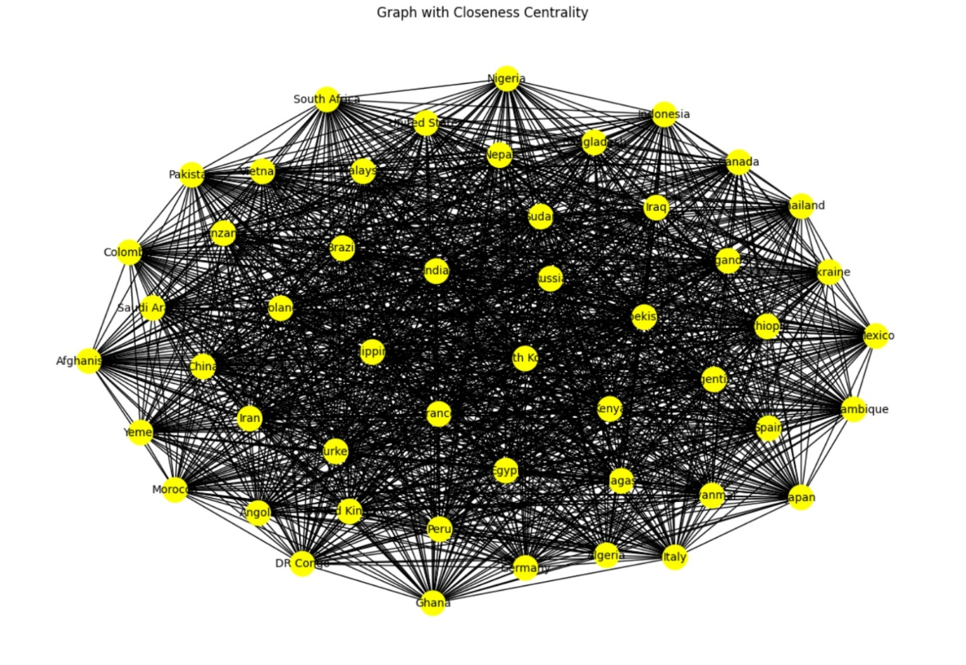

Inference:

Countries with higher closeness centrality have shorter paths to all other countries, making them globally well-positioned for influence.

These might be central economic players, globally connected trade hubs, or diplomatically active nations capable of influencing international outcomes quickly (e.g., USA, China).

Their central positioning facilitates smooth and rapid global interactions, whether through population, economy, or geopolitics.

**Eigenvector Centrality:**

Eigenvector centrality assigns importance to a node based not only on its direct connections but also on the importance of its neighboring nodes. A node is considered more important if it is connected to other important nodes. This centrality measure captures the concept of "prestige" or "influence" in a network, where being connected to influential nodes enhances a node's own influence.

Input:

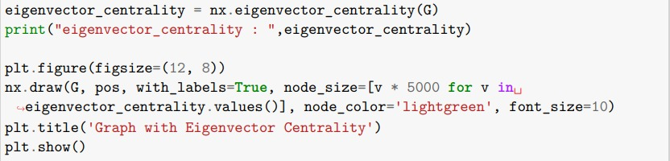

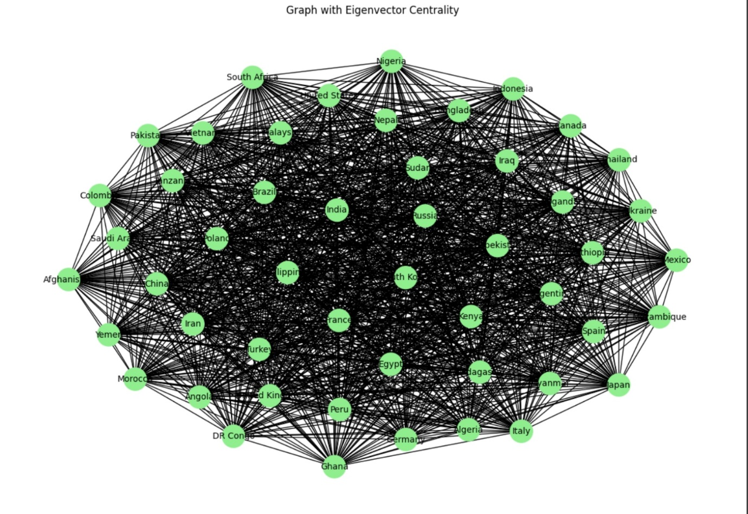

Inference:

Countries with high eigenvector centrality are not only well-connected but also connected to other globally influential countries.

This might represent powerful alliances, strong trade partnerships, or geopolitical coalitions (e.g., G7 countries, economic giants).

Such countries exert systemic influence and leadership globally, making them critical to the overall network structure.

Clustering Coefficient:

The clusteringcoefficient measures how well a node’s neighbors are connected in a network. It helps identify communitystructures by determining the likelihood that two neighbors of a node are also linked. There are two types: the LocalClusteringCoefficient **(**LCC**)**, which calculates the fraction of triangles around a specific node, and the GlobalClusteringCoefficient **(**GCC**)**, which measures clustering across the entire network. A highclusteringcoefficient indicates strong communitystructures (e.g., tightly connected groups), while a lowcoefficient suggests a more randomorsparse network.

Input: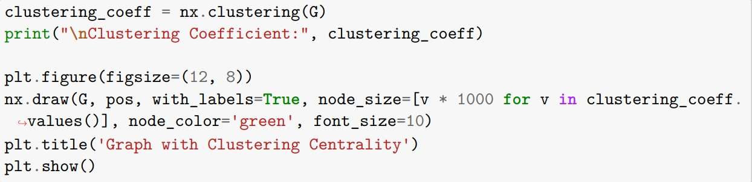

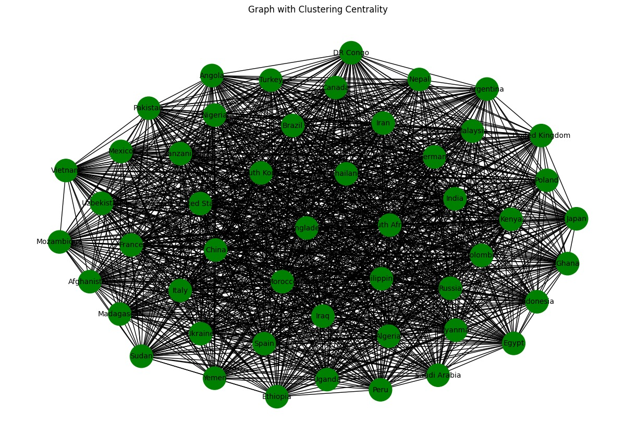

Inference:

Indicates that countries with similar populations tend to form regionaloreconomicclusters. Suggests that population similarities are spreadoutglobally, meaning countries with similar populations do not necessarily have close regional or economic ties.

If high, it indicates a strongcorrelation among multiple countries in terms of population trends. If low, it means population sizes vary widely, and there are fewerinterconnections between countries with similar populations.

K-Means Clustering

Explanation:

K-Means is an unsupervised learning algorithm used to cluster data points into a predefined number of clusters (k). It iteratively assigns each data point to the nearest cluster centroid and then recalculates the centroid positions. This process continues until the clusters stabilize or reach a maximum number of iterations. K-Means is simple, efficient, and commonly used for discovering hidden patterns in unlabeled datasets.

Use Case:

K-Means is ideal when you need to group similar entities without prior labels. In demographic or population studies, it can cluster countries based on various features (e.g., population size, growth rate, density) to reveal natural groupings. This helps in understanding which countries share similar characteristics and can guide resource allocation or policy decisions.

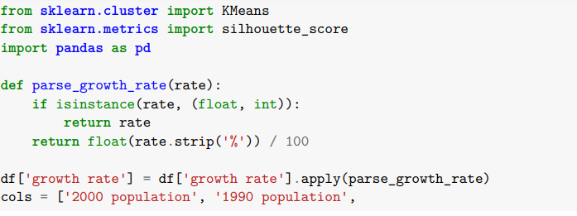

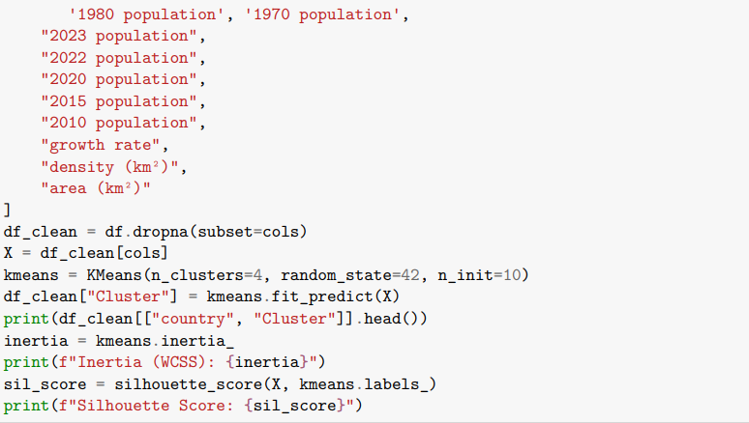

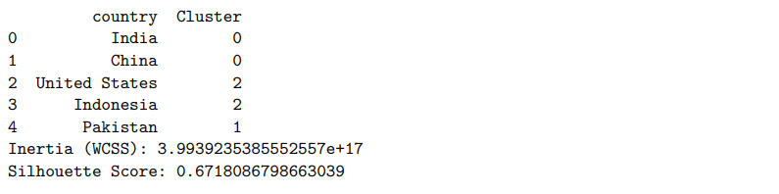

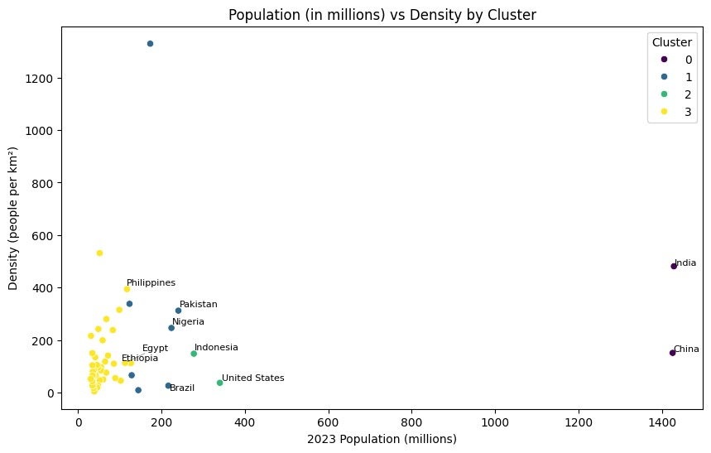

Inference:

The clustering can help identifydemographicsimilarities among countries.

Policymakers can use this grouping for resourceallocation**,** economicplanning**,** andpopulationcontrolpolicies.

Further improvement can be done by optimizingthenumberofclusters **(**k**)** usingtheElbowMethod or adding more relevant features.

The clustering helps identifypatternsinworldpopulationtrends.Countrieswithinaclustersharesimilarcharacteristics, which can be useful for policy**-**making**,** resourceallocation**,** andeconomicplanning.

Random Forest Classifier

Explanation:

Random Forest is an ensemble method that builds multiple decision trees using different subsets of data (bootstrapping) and features. It then combines the predictions of these individual trees via majority voting (for classification) or averaging (for regression). This ensemble approach reduces overfitting and often provides robust, accurate predictions. Random Forests also provide feature importance measures, helping to identify the most influential factors in a dataset.

Use Case:

Random Forest is well-suited for classification tasks with tabular data that may contain both numeric and categorical variables. In population or health contexts, it can classify individuals or countries into risk categories (e.g., High, Medium, Low), identifying key risk factors and handling complex, non-linear relationships effectively.

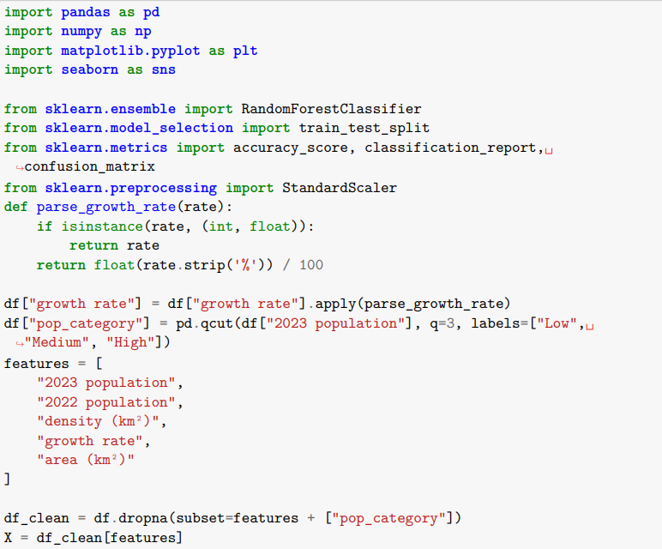

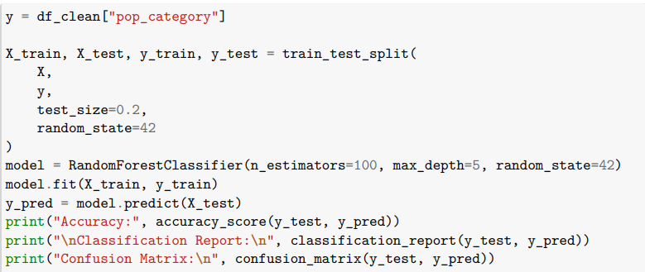

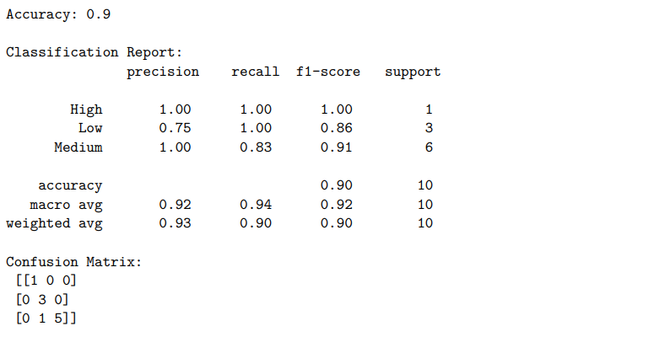

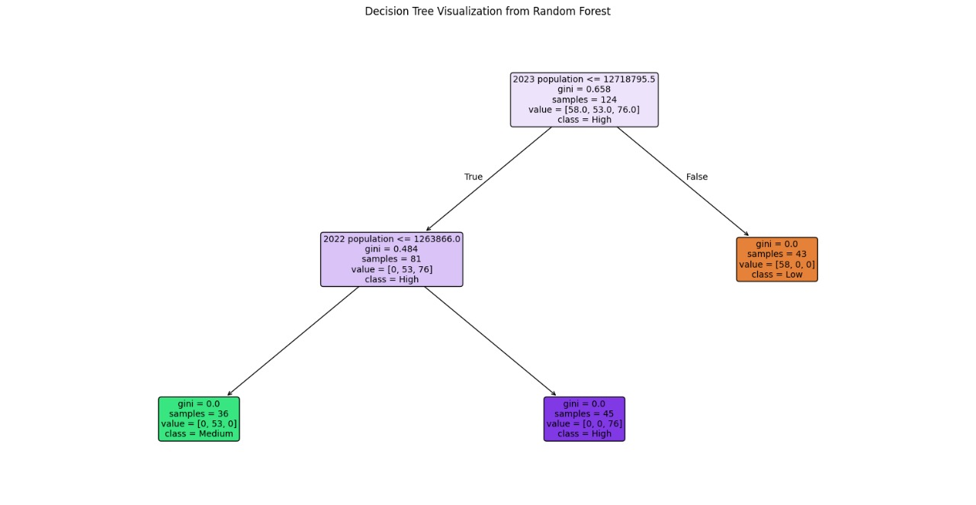

Inference:

Primary Split on Recent Population: The tree first checks whether a country’s 2023 population is below or above a certain threshold (1.7 billion), showing that the model heavily relies on the most recent population count to separate countries into different categories.

Further Division by 2022 Population: If 2023 population is below that threshold, the tree then uses 2022 population to distinguish between Medium and High categories, reinforcing the importance of consecutive-year population figures in the classification.

Single-Path Leave Each final branch leads to a leaf node labeled as Low, Medium, or High, indicating that once both 2023 and 2022 population thresholds are evaluated, the model decisively assigns a population category with no further splits.

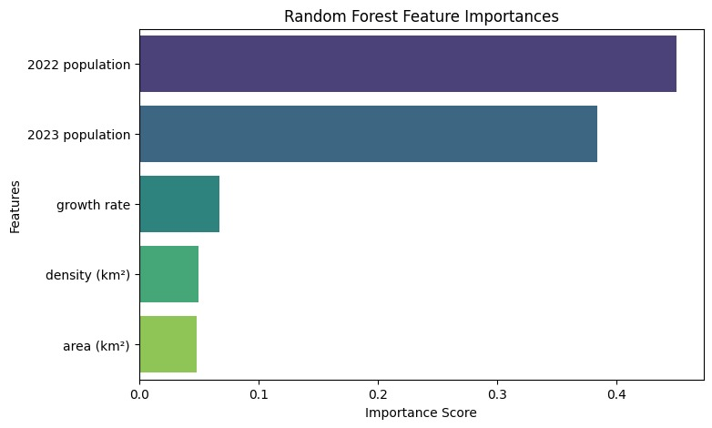

Inference:

2022 population dominates the model’s predictions, followed closely by 2023 population.

Growth rate provides moderate insight, but density and area have minimal impact.

This indicates that recent population figures are the strongest drivers of the model’s classification or prediction.

Logistic Regression

Explanation:

Logistic Regression is a supervised learning algorithm used primarily for binary or multi-class classification. It models the log-odds of the probability of a class as a linear combination of input features. Logistic Regression is known for interpretability, as the coefficients indicate how each feature influences the odds of belonging to a particular class. It also provides probability estimates, enabling more nuanced decision-making.

Use Case:

Logistic Regression is often chosen when you need clear, interpretable results and probability outputs rather than just a class label. For instance, in health risk assessment (e.g., heart attack risk), doctors may prefer a probability of risk to decide on preventive measures. Its relatively simple formulation and ease of calibration make it suitable for many real-world classification problems where transparency is essential.

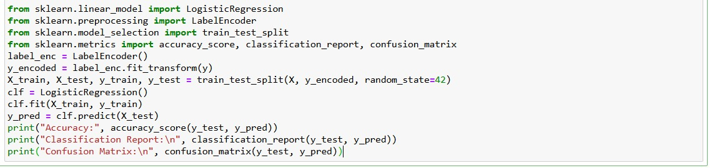

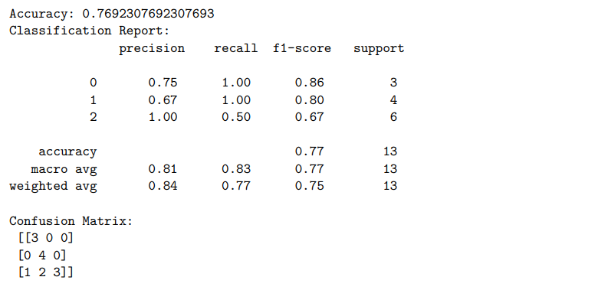

Support Vector Machine (SVM)

Explanation:

SVM is a supervised learning algorithm that finds the optimal hyperplane (decision boundary) to separate classes by maximizing the margin between them. For non-linear data, SVM uses kernel functions (e.g., RBF, polynomial) to transform the data into higher-dimensional spaces, making complex boundaries possible. SVMs can achieve high accuracy and handle high-dimensional feature spaces effectively, given proper parameter tuning.

Use Case:

SVM is beneficial for binary or multi-class classification tasks, especially when data is not linearly separable. By applying kernel tricks, SVM can model complex relationships. In population or health-related projects, SVM can classify high-risk vs. low-risk groups based on multiple features (e.g., demographic indicators, medical factors). Its focus on maximum-margin separation can lead to robust performance, particularly for moderately sized datasets.

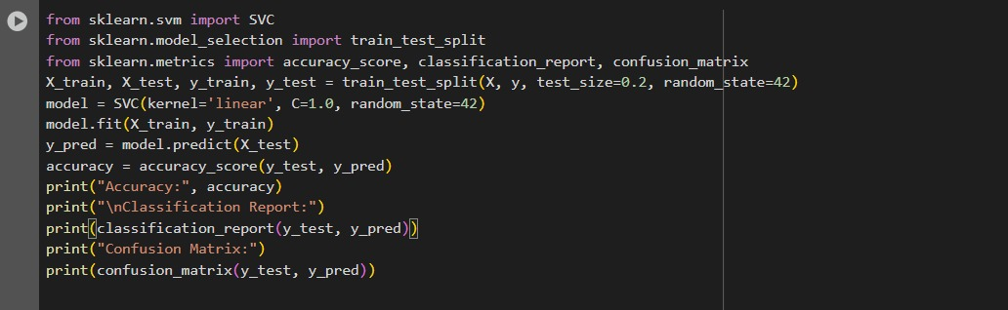

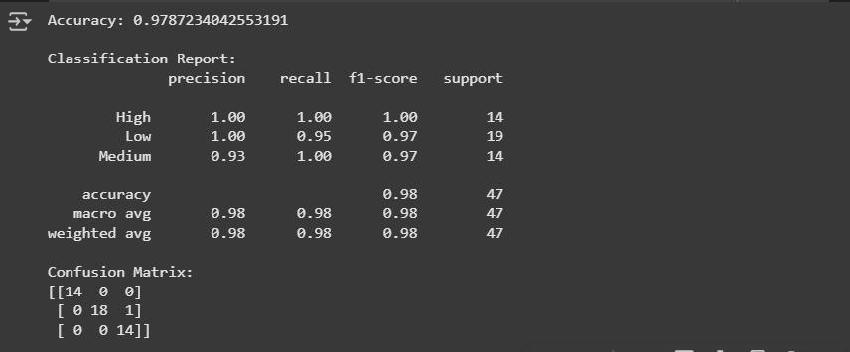

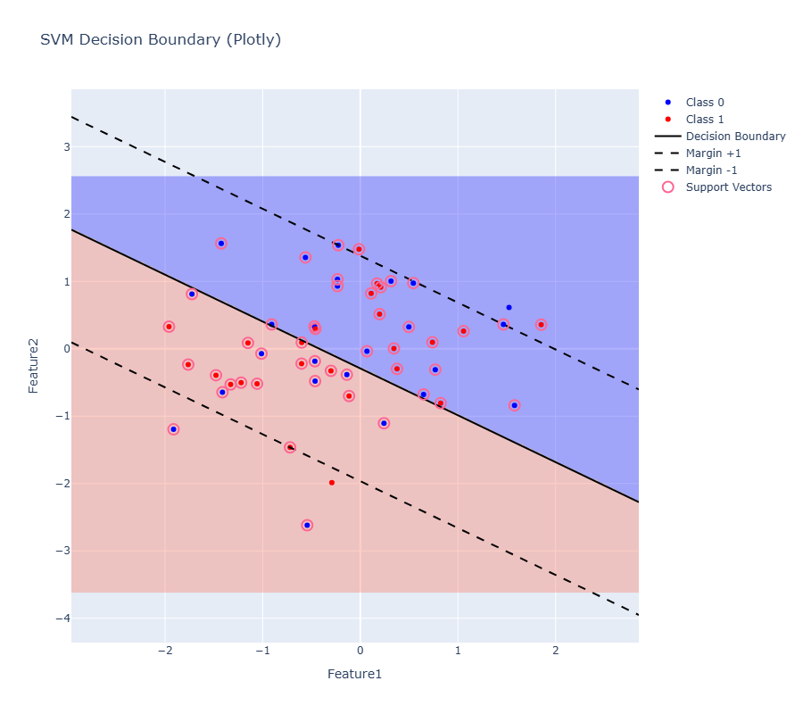

Inference:

Linear Boundary: The SVM uses a straight line (solid black) to separate the two classes (blue vs. red).

Margins and Support Vectors: The dashed lines represent the margin boundaries, and the circled points are the support vectors, which lie closest to the decision boundary.

Clear Class Regions: The shaded areas (blue and pink) show how the SVM predicts each class, with Class 0 in the upper region and Class 1 in the lower region.

Model Explanation

K-Means Clustering:

Discovering Unsupervised Demographic Groupings-Revealing Natural Groupings: K-Means automatically partitions countries into clusters based on shared demographic attributes, such as population size, density, or growth rate. This helps uncover distinct subgroups without requiring any prior labeling.

Unsupervised Exploration:By not relying on predefined categories, K-Means allows you to discover novel patterns or unexpected similarities among countries. This exploratory perspective can lead to fresh insights into demographic structures.

Random Forest Classifier:

Identifying Key Factors and Ensuring Robust Classification

-Identifying Key Influencers: Random Forest pinpoints the most significant factors (population density, growth rate) when assigning countries to categories ( Low, Medium, High). This ranking of feature importance can guide policy decisions or resource allocation.

Ensemble Robustness: Combining multiple decision trees results in stable predictions, reducing the chance of overfitting. This ensemble method can produce more reliable classifications, offering confidence in the model’s conclusions about population segments.

Logistic Regression:

Interpretable Probability-Based Population Categorization

Probability-Based Categorization: Instead of simply assigning a category, Logistic Regression estimates the probability of belonging to each group (the likelihood a country is in a High population bracket). Such probabilities can help prioritize which areas need closer attention or support.

Interpretable Coefficients:Logistic Regression clearly shows how each demographic feature influences the odds of a country falling into a particular category. This transparency can support policymakers or researchers in pinpointing the most critical levers to address.

Support Vector Machine:

Maximizing Boundary Separation for Enhanced Accuracy

Maximum Margin Separation: SVM strives to draw the most effective boundary between different categories, ensuring a clear division between groups like High and Low population. This can sharpen the focus on which countries lie near or far from critical thresholds.

Flexible Kernel Methods: For non-linear relationship such as complex population dynamics SVM can employ kernels (like RBF or polynomial) to capture more intricate patterns. This versatility can boost accuracy when simpler assumptions do not hold.